Gold in 2021: Persistent Inflation and a Fed Pivot Provide Hints About 2022
GBI Special Report

The big story in 2021 was the jump in inflation. And then in Q4 the Fed’s announcement that it will raise interest rates multiple times in 2022. Gold ended last year slightly lower, but with new policy and economic shifts emerging, is gold poised for a reversal to the upside?

This report briefly examines the performance of gold and other major asset classes during the fourth quarter and full year of 2021, along with a review of the conditions that could impact the precious metal in the new year.

Q4: Gold and Silver Rebound

Most assets were relatively flat in Q3 of last year. Gold slipped 1.2%, and silver dropped 16.5%. But both rebounded in Q4.

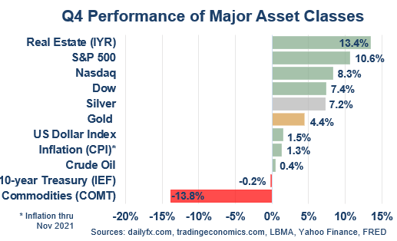

Real estate led all comers last quarter, beating out the major stock indexes, which also logged healthy gains. Gold rose 4.4%, while silver gained 7.2%. Commodities took it on the chin.

2021: Outside Forces Pressure Gold

2021 ushered in some long-desired optimism on the part of investors and consumers, despite lingering effects of the pandemic. The economy rebounded and markets soared.

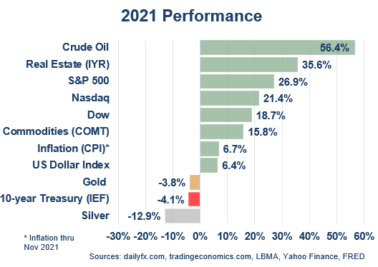

Outside of US Treasuries, only gold and silver fell. Gold ended the year down 3.8%, and silver fell 12.9%.

Which begs the question…

Why Was Gold Down with Inflation Running Hot?

It is somewhat puzzling that gold would be weak in a year that saw inflation rise both abruptly and significantly. A deeper analysis provides some answers:

- For most of 2021 the market accepted the message that inflation would be transitory. Investors did not buy an inflation hedge since they thought the CPI would come right back down.
- According to multiple sources, more cash poured into equity funds in 2021 ($900 billion) than the last 20 years combined. Clearly it was a risk-on trade.
- The U.S. dollar, typically inversely correlated to gold, rose 6.4%.
- Economic growth beat most expectations. 2020 fears turned to 2021 optimism.

The question in front of investors now is, do these trends continue—or do they ease or even reverse and lead to higher gold prices?

The 2022 Road Map

While market and economic risks are always present, it is hard to overstate the number of potholes in the road as we enter the near year. The following factors could impact the gold market in 2022.

Pandemic Persistence. Omicron appears less virulent than previous variants but is more contagious, which means that hospitalizations could remain high. The Omicron variant was responsible for at least 41% of all U.S. Covid cases in December. Its spread could suppress consumer demand and exacerbate supply-chain bottlenecks.

Stubborn Inflation. Food prices are estimated to rise 5% in the first half of 2022, according to research firm IRI. Wheat and corn were each up over 20% in 2021, while soybeans hit a third consecutive year of rises. Warnings of prolonged food inflation persist, including from the CEO of fertilizer giant Yara International: “I want to say this loud and clear right now: we risk a very low crop in the next harvest. I'm afraid we're going to have a food crisis.” Consumer analyst Julie Ramhold at DealNews.com was equally bleak about higher food costs: “I really don’t think there’s any way to escape.”

It is indeed a global phenomenon. UK inflation is already over 5% and is expected to hit 6% in 2022, what would be the highest level in 30 years. Alcoa halted aluminum production in Spain for 2 years due to soaring energy costs, Europe's second-largest aluminum plant, while Europe's biggest aluminum smelter cut output the week before. India's market regulator ordered a year-long suspension of futures trading in key farm commodities in an effort to fight inflation. And of course, Turkey has a serious inflation problem, its annual rate recently hitting 36%.

Citizens feel it, too. According to a Bankrate survey, 26% of Americans believe their financial situation will be worse in 2022, and of those 70% blame inflation. “People are getting worried about inflation continuing to rise,” reports Forbes.
Some parts of the current inflation spike probably are transitory—but now wages are rising, which could keep inflation elevated for years. If so, the Fed will be under increasing pressure to raise interest rates. Which ushers in problems of its own…

Interest Rate Increases. The Federal Reserve announced it will raise interest rates in 2022. “It’s going to be the first time in almost two years that the Fed’s incremental decisions might force investors or consumers to become a little more wary,” says David Schawel, CIO at Family Management Corporation.

Surprisingly, gold has historically risen during rate hike cycles. It tends to fall at the initial hike, but in the last four periods it has ended anywhere from 21% to 28% higher.

One must wonder if rate increases will take some air out of the economy or stock market. Especially when combined with a reversal in the Fed’s emergency asset purchases that have been in place since March 2020.

Gold Demand. The trend of central bank gold buying continues, with global reserves now at a 31 year high. As a group they have been net buyers since 2010, and this shows no signs of letting up. According to a survey by the World Gold Council, for the first time in years the top reason behind central banks in emerging markets buying gold is its “performance during crisis situations.”

Meanwhile, Comex gold deliveries in 2021 were more than triple the 15-year average. In China, retail gold sales have rebounded, with the strongest sales surprisingly coming from 20- and 30-year-olds. In India, gold imports passed pre-pandemic levels last year, including a 123% increase vs. 2020.

Fed Watch. Alongside the normal rotation of voting members, the Biden administration will fill three vacant seats on the Fed’s Board of Governors. Public comments from the other three Federal Reserve Bank presidents suggests that the 2022 committee will be more “hawkish.”

Meanwhile, the Fed's commitment to phase out Libor is not completed (as was projected to end last month). According to the Financial Times, there are still $230 trillion in existing contracts that rely on the benchmark. This marks the moment when the past four years of preparation to live without it goes into effect. Dixit Joshi, group treasurer at Deutsche Bank, said “It’s one of the biggest transitions in financial markets in decades. This is a milestone for the regulators since the great financial crisis about lessons learned.”

Last, US debt continues to not only grow, but according to Treasury data it increased in December by half the increase seen in all of 2021.

Frothy Investment Markets. By almost any measure, financial markets remain frothy, if not outright bubbly. Public and private equity are both expensive, real estate prices are high in most advanced economies, meme stocks and crypto assets are still arguably in a craze, and government bond yields remain ultra-low. Any sort of “normalization” process could deflate asset prices—and drive investors to gold.

Midterm Elections. While not until November, it goes without saying that the US is experiencing an elevated level of partisan polarization, gridlock, and radicalization. Democrats have a minor advantage in the House and a thin majority in the Senate; since some voters seem frustrated with President Biden’s handling of inflation and other issues, Republicans would be able to block any legislative move by winning one chamber. This will likely push Democrats to make big changes before the election, including finally passing their social spending bill and perhaps higher taxes, the latter of which could hurt stocks.

U.S. Dollar. Most analysts agree the first couple of months of 2022 could be kind to the dollar. The Fed’s shift toward tighter policy coincides with the People’s Bank of China pivoting toward monetary loosening. However, a number of analysts see the dollar as vulnerable, based on a positive backdrop for risk and commodities, along with simple overvaluation. Also, some chartists say the dollar has broken down through support.

Military Interventions. President Biden has repeatedly warned Russian President Vladimir Putin that he is prepared to “respond decisively” if Russia invades Ukraine. Some argue the Russian economy has become more resilient to sanctions than it was in the past, so such threats may be less of a detriment, making an invasion more likely.

Meanwhile, China has increased its military pressure on Taiwan and in the South China Sea, where territorial disputes continue to brew. And Iran is now on the threshold of becoming a nuclear state, with negotiations going basically nowhere. In response Israel is openly considering strikes against Iranian nuclear facilities.

Biden recently signed a $768 billion defense policy bill, what was a major increase in military spending.

2022 Points to a Necessary Crisis Hedge

We think Hilary Allen, law professor at American University, asks a good question. “Is the current moment the dot-com bubble—or the lead-up to the 2008 financial crisis? If it is just a dot-com bubble, it sucks for investors. But if it is 2008, then we are all screwed, even those of us who aren’t investing.” We think either answer argues for a hard asset hedge.

The circumstance of stubborn inflation, elevated political conflicts, and overpriced stock and real estate markets creates an ideal scenario for gold.

The most likely path ahead is one where gold continues to offer a meaningful and necessary hedge. It would not be surprising to see the gold price achieve new record highs in 2022.

